Power Darts
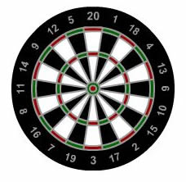

On a dartboard where the "doubles" count as squares and the "trebles" count as cubes how many 3 dart finishes are there starting from 501, finishing on a "double".
e.g. 20, "double" 9, "double" 20:
20 + 9² + 20² = 501

